Software Requirements Specification
BE Projects 2011-12

GESTURE RECOGNIZING ROBOT
<Group Code>
Prerna S.Bakhru
Reshma K. Ramanan
Bhagyashree B.Patil
Chandni S. Kateja

Table of Contents
- Introduction
1.1 Problem Definition 3
1.2 Definitions, Acronyms and abbreviations 3
  - Scope 4
  - References 4

Overall Description 5

Details 7

3.1 Functionality
3.2 Supportability
3.3 Design constraints
3.4 On line user documentation and help requirements
3.5 Interfaces

Quality control 8

Risk management 9

6 Future management 9

Introduction

1.1 Problem Definition
With the improvement of technology, Human Machine Interaction (HMI) is getting more and more important. In order to interact with mobile devices and computers, static keys/buttons, track path devices and touch screens have developed respectively. We believe that the next concept of HMI will let people use computers or mobile devices without touching. Gesture recognition and motion tracking are the next improvement of interaction with mobile devices.

Controlling Mobile Devices is not an easy task while driving car or mobile device is located away from user via touching screen or pushing button. Our Gesture Recognition System will be the solution of getting out of an obligation of touching the screen or pushing the buttons of mobile phones in order to make a call, control the menu, take a picture etc. By detecting the hand movements of human body, there will be no necessity of touching on mobile phones.

We know that some applications related with gesture recognition are available for computers. However, logic of Controlling a robot using hand human gestures and then making them perform any function can been used in many other heavy work practical applications. Due to all of these reasons, development of this “Gesture Recognizing Robot” will be a breakthrough innovation.

Definitions, Acronyms and Abbreviations

Term | Definition
Visual Depth Information | Proper visual recognition of depth or the  relative distances to different objects in space
Gesture Recognition | Mathematical interpretation of a human gesture by a computing device
Pattern matching | The act of checking some sequence of tokens for the presence of the constituents of some pattern.
SRS | Software Requirements Specification

GRE Gesture recognizing robot

1.3. Scope

The main goal of this project is to start controlling a robot using real time human hand gestures. The same logic can then be used to control any object or electronic devices using gestures.the existing presence of touch used interfaces can be gradually changed to gesture used interfaces . the tests can be then even be extended to voice controlled robots.

The ideas and algorithms used in Controlling robots using Gesture Recognition System and motion tracking can be used in many other areas like security systems and mechanical field related applications.
.

References

[IEEE] The applicable IEEE standards are published in “IEEE Standards Collection,”
2001 edition.

Gesture recognition basics:

http://en.wikipedia.org/wiki/Gesture_recognition

Body tracking using kinect:

http://research.microsoft.com/en-us/news/features/kinectskeletal-092711.aspx
3. documents of Robotics and Automation Group in NASA Johnson Space Center

- This citation is used as a model of reference: [IEEE Std 830-1998]

Overall Description

This section of Software Requirements Specification (SRS) describes all general factors of the product and its requirements.

Product Perspective
The Kinetic Space provides a tool which allows everybody to record and recognize customized gestures using depth images. The software observes and comprehends the user interaction by processing the skeleton of the user. The unique analysis routines allow to not only detect simple gestures such as pushing, clicking, forming a circle or waving, but also to recognize more complicated gestures as, for instance, used in dance performances or sign language.

Since this is a open source program under the Microsoft so the source code is free to download. its a framework where you can create and edit. And due to its open Source nature you can modify it according to your need.

Product Functions
Using a Kinect, we are streaming motion capture data in real time to the gesture recognizer. Two different sensors can sense your hand gestures and considering all the facts make accordingly decisions regarding the movement of the robot.

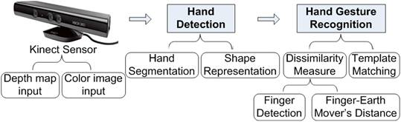

User Characteristics:
User Interface Controller function is the last part of the project. This includes the moment of the robot with respect to the hand gestures. The FORWARD , BACKWARD, LEFT and RIGHT moments shall be achieved.

Constraints Assumptions and Dependencies:

Regulatory Policies:
Damaging one of the two sensors that recognizes the hand movements of the user can cause KINECT to work improperly.

Hardware Requirements:
Computer with a dual-core, 2.66-GHz or faster processor; Windows 7–compatible graphics card that supports DirectX® 9.0c capabilities;2-GB RAM (4-GB RAM recommended)
Software Requirements:
Windows 7 (x86 or x64);Visual Studio 2010 Express (or other 2010 edition);Microsoft .NET Framework 4.0.
Criticality of the Application:

In case of attempt to make hand movements with more than one hand at the same time, algorithms and logic needs to be modified.

Details

3.1 Functionality:
The basic methodology of GRR can be laid down as follows:=
- Capture frame containing some gesture presentation.
- Extract hand gesture area from captured frame.
- Determine gesture by pattern matching.
- Determine control instruction, corresponding to matched gesture, and give that instruction to specified robotic system.

Since the GRR consist of two major parts; the functionality shall be divided in two parts
- Gesture recognizing engine (MS KINECT)
- User interface controlling.

GESTURE RECOGNIZING ENGINE:-

The following is the flow diagram for gesture recognizing system
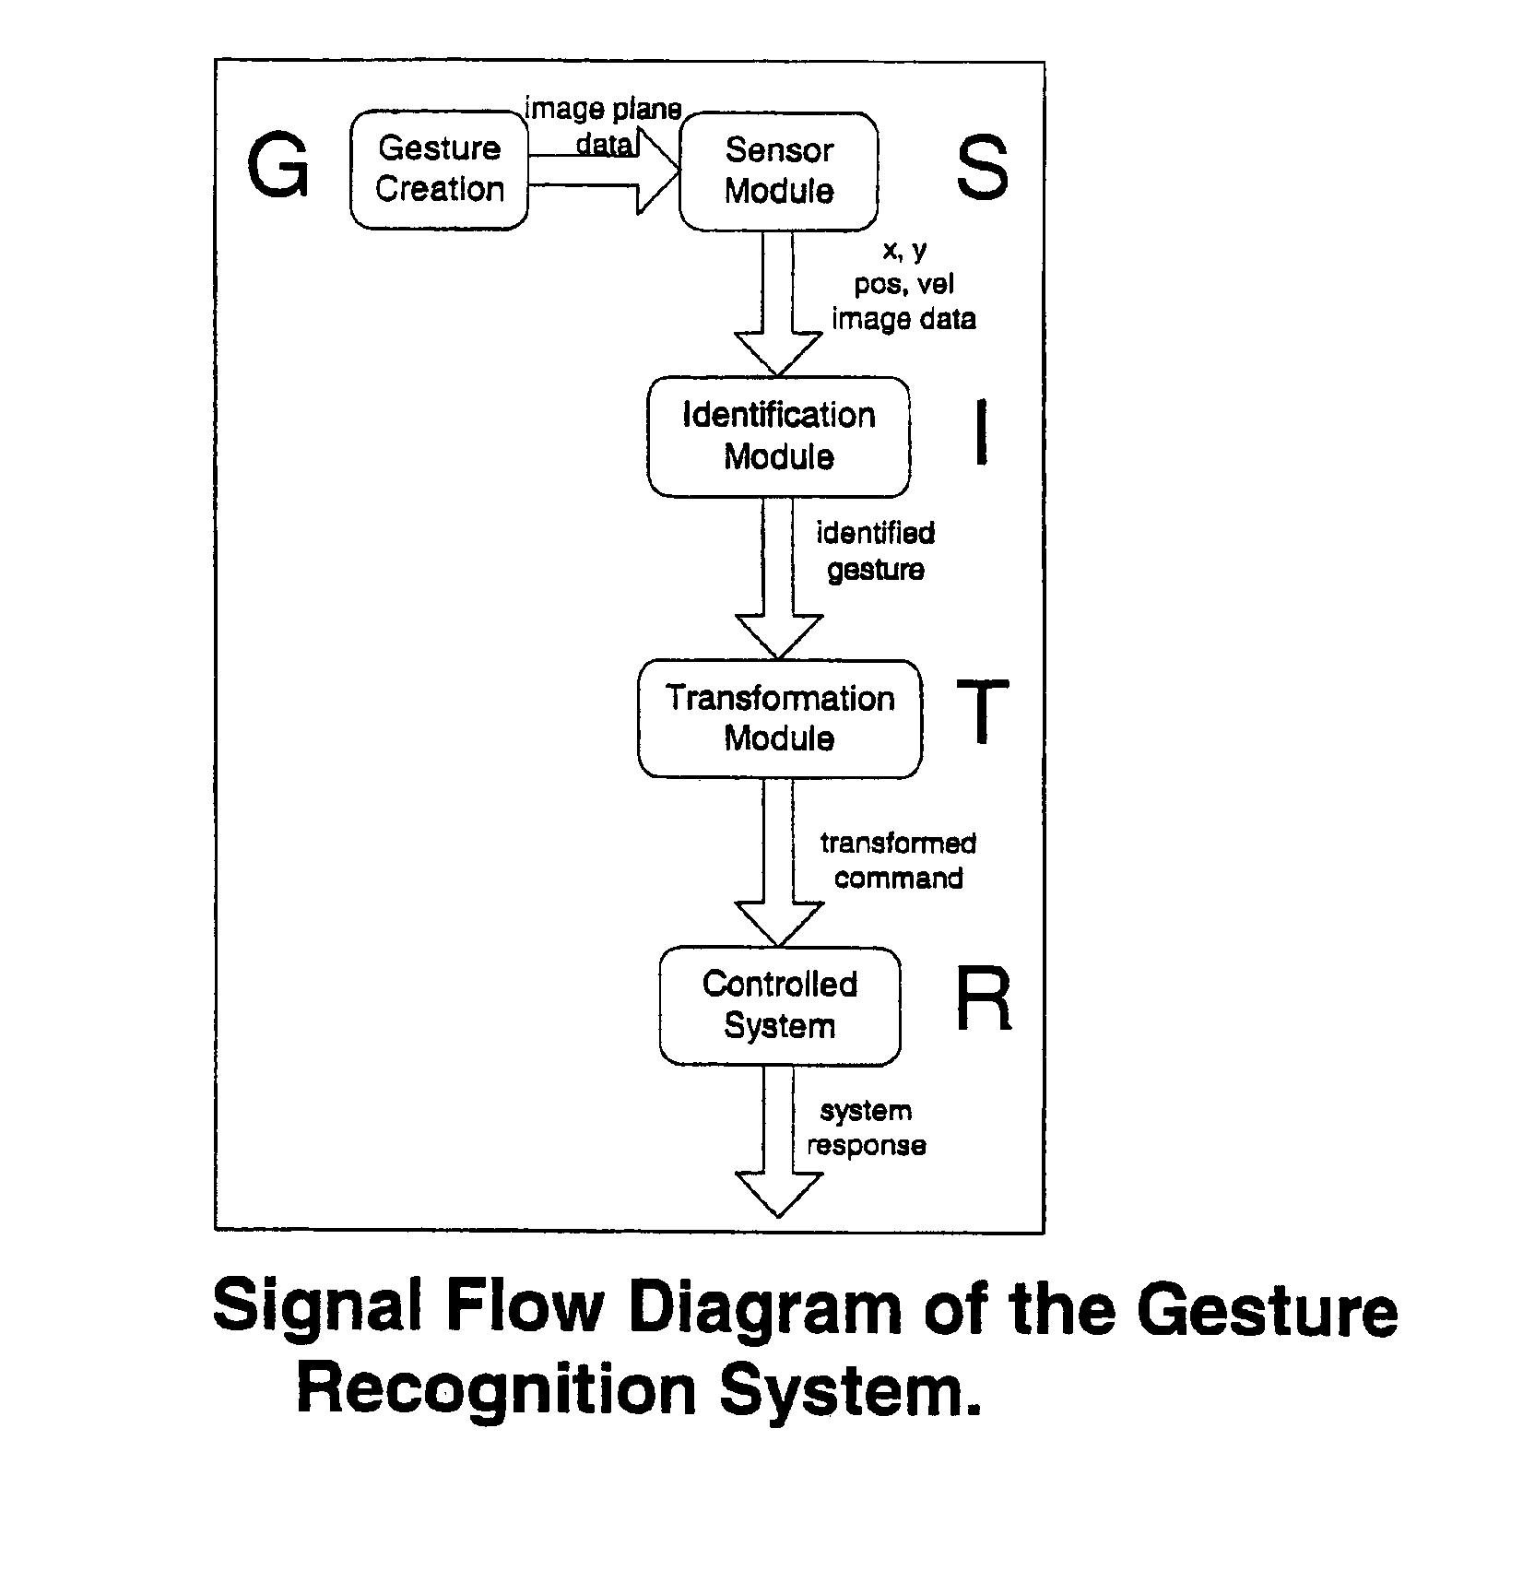

kinect a camera system uses a regular camera and will capture images of you and your surroundings, and an IR(infrared) sensor that can pick up movement within a 3d space.
it provides full-body 3D motion capture(a 640x480 depth map in real time), as well as face and voice recognition.

Supportability:

The main feature of the Kinect is that it provides a 640x480 depth map in real time, which can basically indicate which objects are near and which are far in a given scene. This is highly valuable for use in obstacle avoidance and effective navigation in robots.

On-line User Documentation and Help System Requirements:

Access to the IEEE papers on existing projects on “Gesture reorganization” would be of primary important. The principal source of material is online sites related to MS kinect and the accessed IEEE papers and topics on “Recognizing and interpreting gestures on a mobile robot”.

Interfaces

USER INTERFACES: This object contains hand information; position and orientation of the hand. Control actions are done on the basis of the recognized gestures. So proper functioning of the camera and sensors are required. Position and orientation of the hand will be continuously updated by the camera and sensors since we have a real time working system.

This object contains the programming of gestures and creating a library of programs for different kind of gestures using Visual C# or C++.

Hardware Interfaces:

This object includes the interfacing of the kinect with the PC . its through this interface that the programs on the kinect kit can be accessed by users on computer.

Communication interfaces:

Interfacing PC with the robot (SPARK V) through ZIGBee Wireless Communication. The final control functions are formed and accordingly transferred to robot for robot movement.

Quality Control

Test Data:

The bot will be initially programmed to follow simple four instructions
- FORWARD
- BACKWARD
- LEFT
- RIGHT.
Further we also plan to define gestures such as SPEED UP and SLOW DOWN using gestures.

Risk Management
The main requirement of this project is the MS Kinect Sensor Kit and SPARK V bot.
The risk that are likely to occur in this project can be laid down as follows in the order that we might face them:-

- Programming using visual C# or C++
- And getting required output as moment of the robot.

Programming:-

The programming to be done needs good knowledge on C# which we lack and we are still learning the same.
Study of sample programs stored in Kinect SDK will help in understanding the concepts of Skeletal Tracking using Kinect and then to modify those programs as per requirement.

Output:

To achieve the desired results we need to interface SPARK V with PC using the ZigBee Wireless Communication. The robot may have problems considering the background colours of images in our stored databases and the real time images. Kinect sensors might have hard time functioning in sunny areas,although it can navigate perfectly without daylight.

FUTURE DEVELOPMENT

After performing the basic movement functions of our robot ,We plan to design our project using voice controls available in Kinect kit. Different voice signals can be used for controlling robot. Using these gestures and voice signals we can even try to design any real time mechanical application using this robot.

